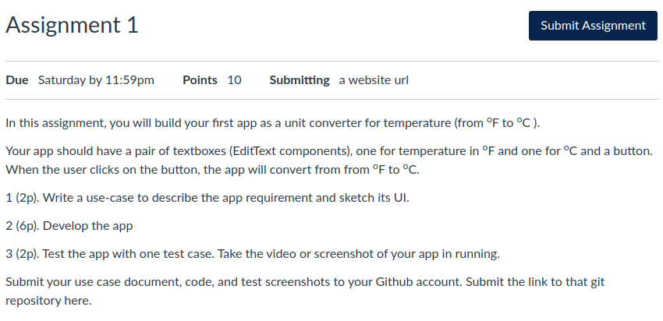

1. As a user, I want to convert degrees in F to degrees in C

2. Done

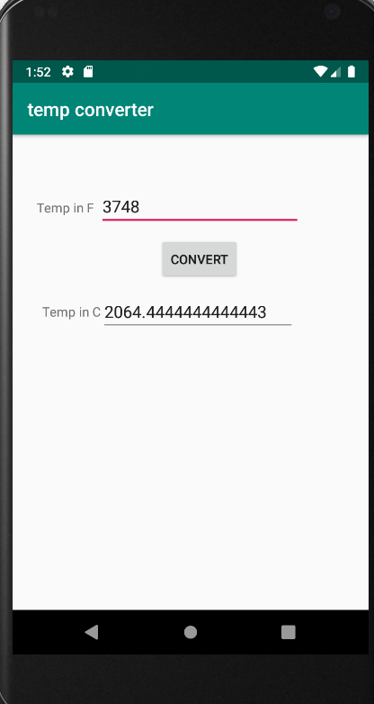3. Test 1: